
VEDIC - VDIA ENGINEERING DESIGN INNOVATION CENTER

For Skill & Entrepreneurship Development

NAME OF COURSE: CYBER SECURITY AND ETHICAL HACKING

REPORT ON: ETHICAL HACKING OF WINDOWS 7 OS USING LINUX

SUBMITTED BY:
NAME: AMRUTHA DHIRAJ GOJE
YEAR: 3RD YEAR (5TH SEMESTER)
DEPARTMENT: COMPUTER ENGINEERING
COLLEGE: MKSSS CUMMINS COLLEGE OF ENGINEERING FOR WOMEN, NAGPUR

GUIDED BY: KAUSHIK KHOBRAGADE
SUBMITTED TO:

CYBER SECURITY AND ETHICAL HACKING
ETHICAL HACKING OF WINDOWS 7 OS USING LINUX
A VirtualBox-Based Approach ~ By Amrutha Dhiraj Goje

INTRODUCTION
In the evolving landscape of cybersecurity, ethical hacking plays a crucial role in identifying and mitigating system vulnerabilities before malicious actors can exploit them. This report focuses on a practical implementation of ethical hacking techniques using a controlled virtual environment. The target system is a Windows 7 operating system installed in Oracle VirtualBox, while the attacking machine is a Linux-based distribution (e.g., Kali Linux) also running within VirtualBox.
Windows 7, despite being outdated and no longer supported by Microsoft, is still used in legacy systems and remains a valuable platform for learning exploitation techniques. The Linux system, equipped with penetration testing tools like Metasploit, Nmap, and Exploit-DB, serves as the attacker's machine to simulate real-world vulnerabilities.
By using VirtualBox, this approach ensures a safe, isolated, and replicable environment for executing exploits and understanding the attack lifecycle—from reconnaissance and vulnerability scanning to gaining access and post-exploitation. All activities are conducted under the scope of ethical hacking principles, emphasizing learning, defence strengthening, and cybersecurity awareness. This practical demonstration not only deepens the understanding of known vulnerabilities in older operating systems like Windows 7 but also provides insight into securing modern systems against similar attacks.
PREREQUISITE
Virtual Machine Setup
- One VM with Windows 7 OS (target machine)
- One VM with Kali Linux OS (attacker machine)
- Internal network configuration for VM-to-VM communication
PROCEDURE
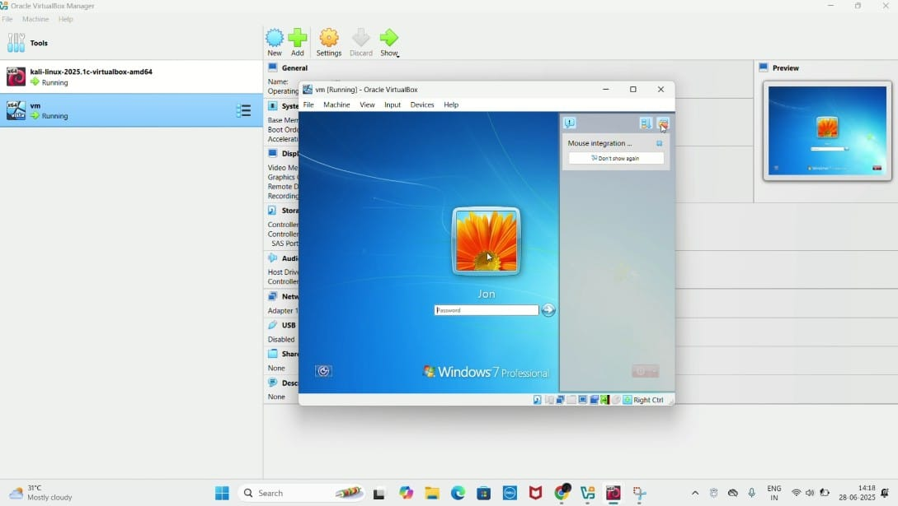
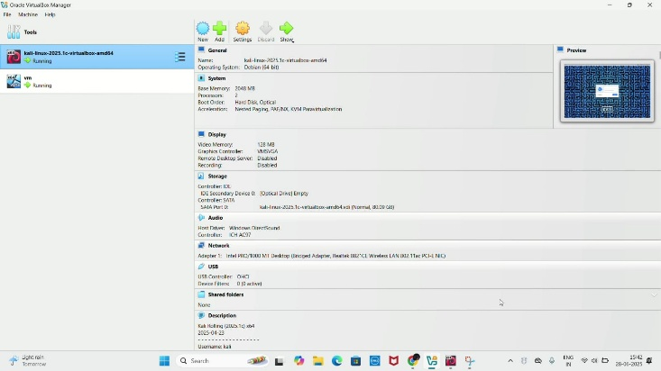
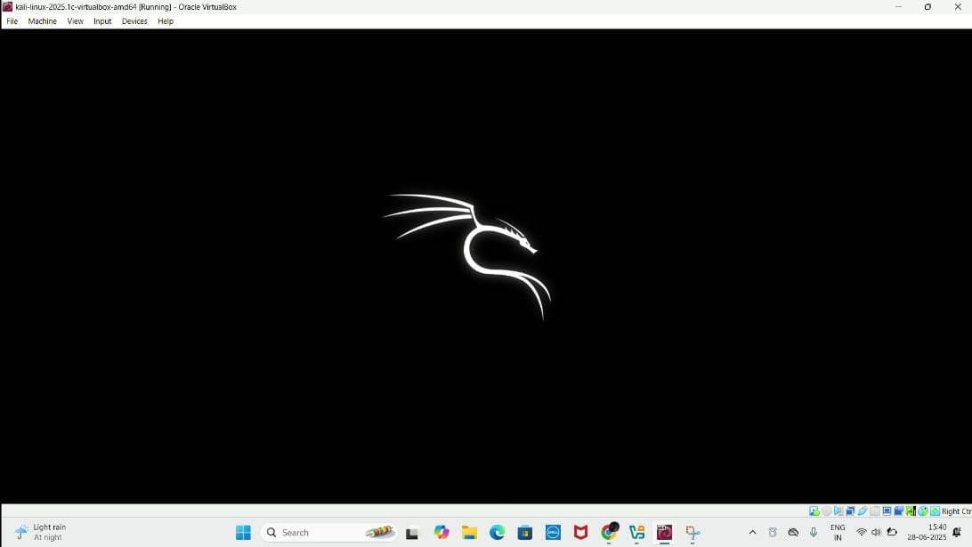
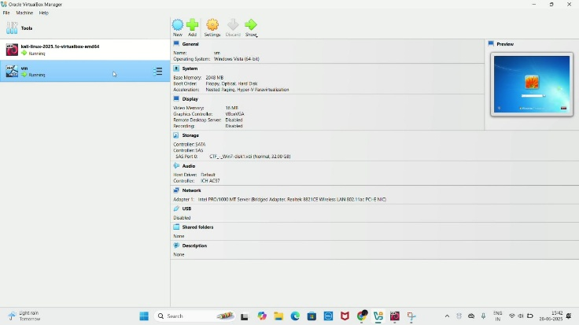
STEP 1: Launching Virtual Machines
Start both the Windows 7 virtual machine (target) and the Kali Linux virtual machine (attacker) using Oracle VirtualBox.

STEP 2: Opening Kali Linux Terminal
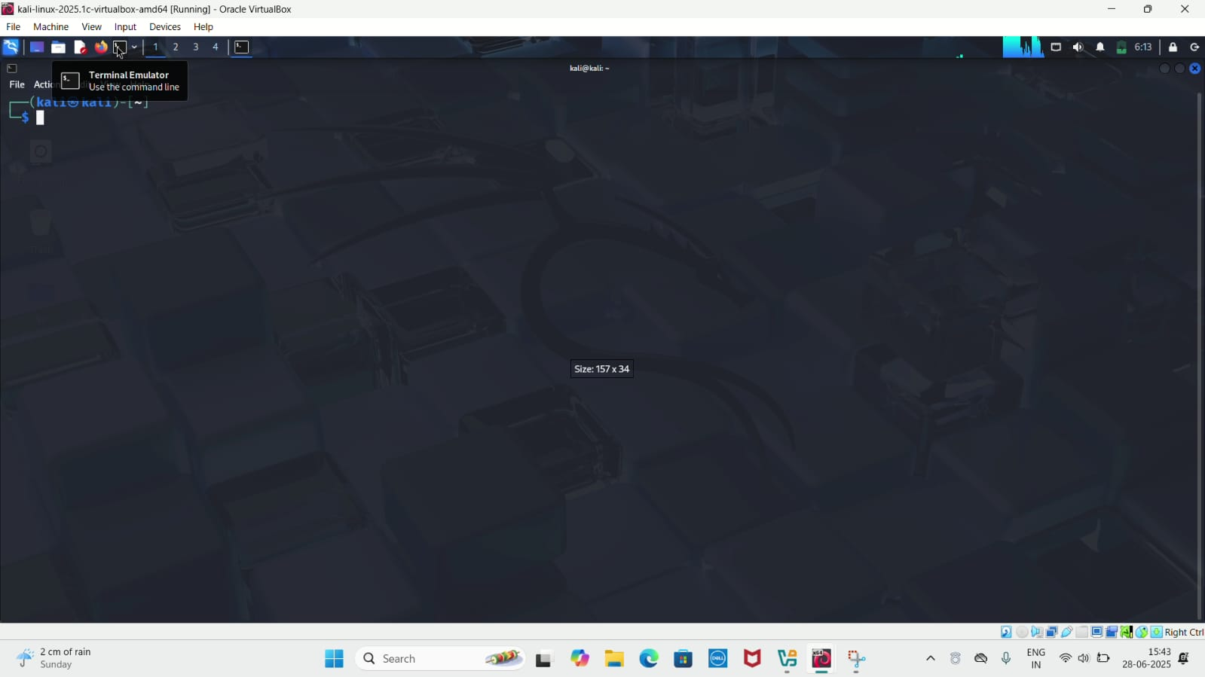
Access the terminal in the Kali Linux environment to begin the penetration testing process.
STEP 3: Switching to Root User
Use the command sudo su to switch to the root user. The system will prompt for the root password — enter it to gain administrative privileges.

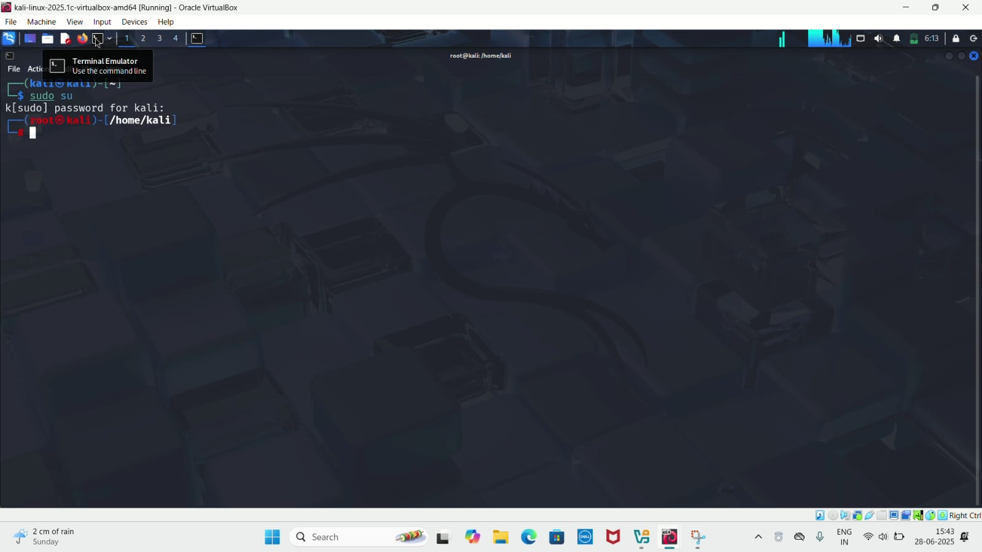
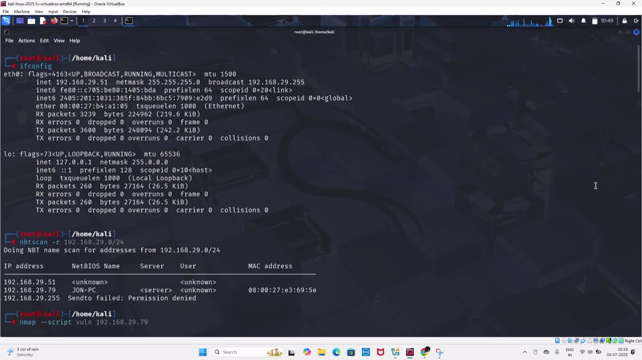
STEP 4: Identifying IP Address of Kali Linux
Execute the command ifconfig to view the network configuration and determine the IP address assigned to the Kali machine.
STEP 5: Scanning the Network
Run the command nbtscan -r 192.168.29.0/24 to scan all devices connected to the same subnet. This will list active hosts along with their names. Identify the Windows 7 machine, which appears with the NetBIOS name JON-PC. Its IP address in this case is 192.168.29.79.
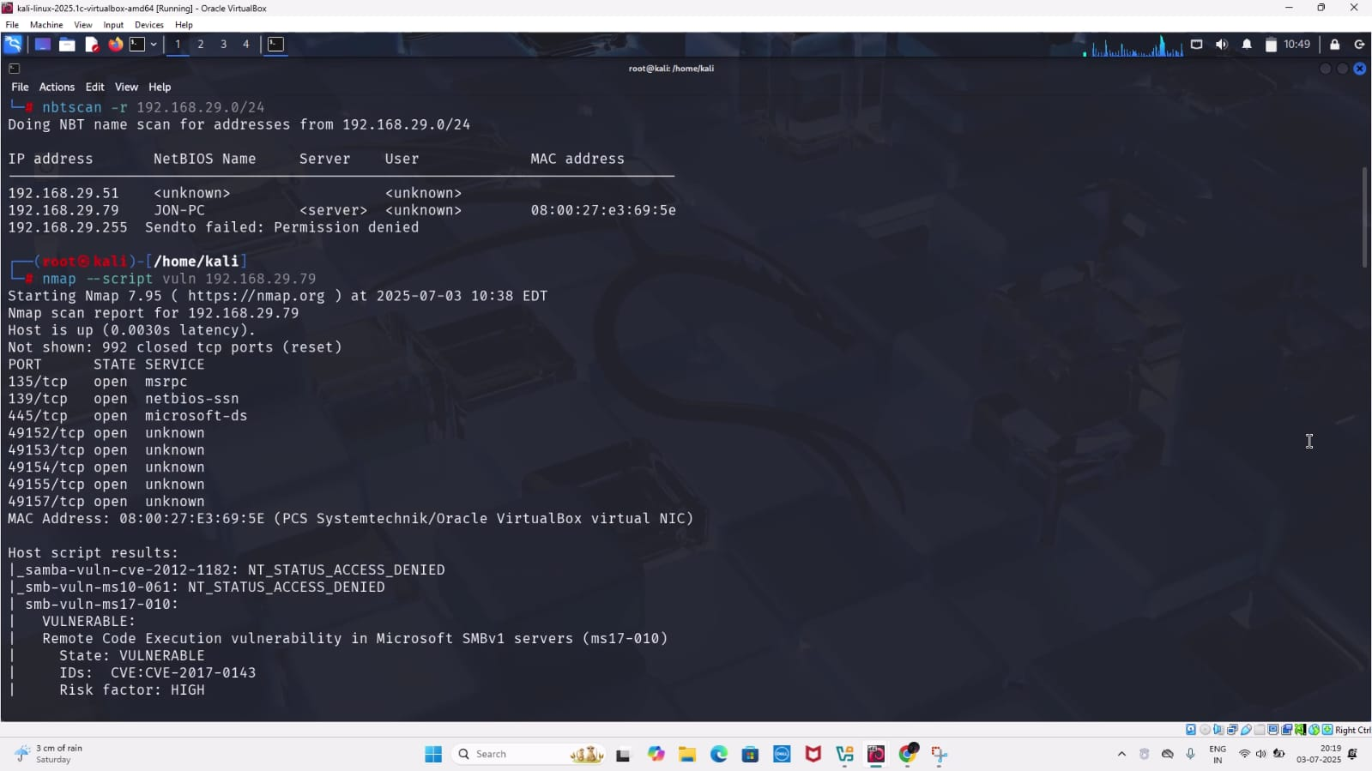
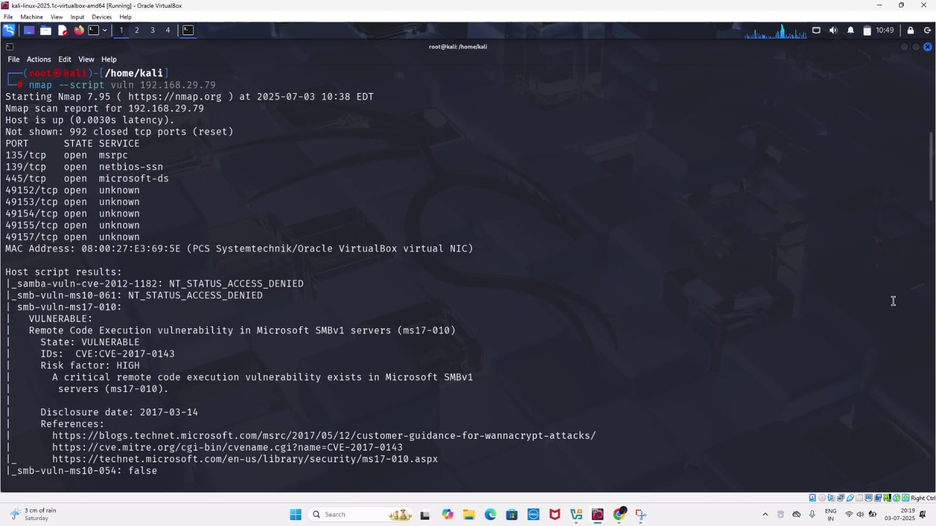
STEP 6: Vulnerability Scanning with Nmap
Use the following command to scan the target system for known vulnerabilities: nmap --script vuln 192.168.29.79
From the scan results, we identified a critical vulnerability: CVE-2017-0143, commonly known as EternalBlue.

STEP 7: Launching Metasploit Framework
Start Metasploit by executing the command:
msfconsole
This opens the Metasploit Framework (msf6), a powerful penetration testing platform used to discover and exploit vulnerabilities.
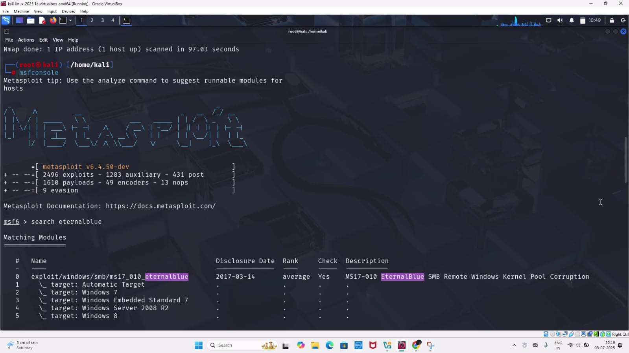

STEP 8: Searching for EternalBlue Module
Inside Metasploit, search for the EternalBlue exploit using:
search eternalblue
A list of available EternalBlue exploits is displayed.
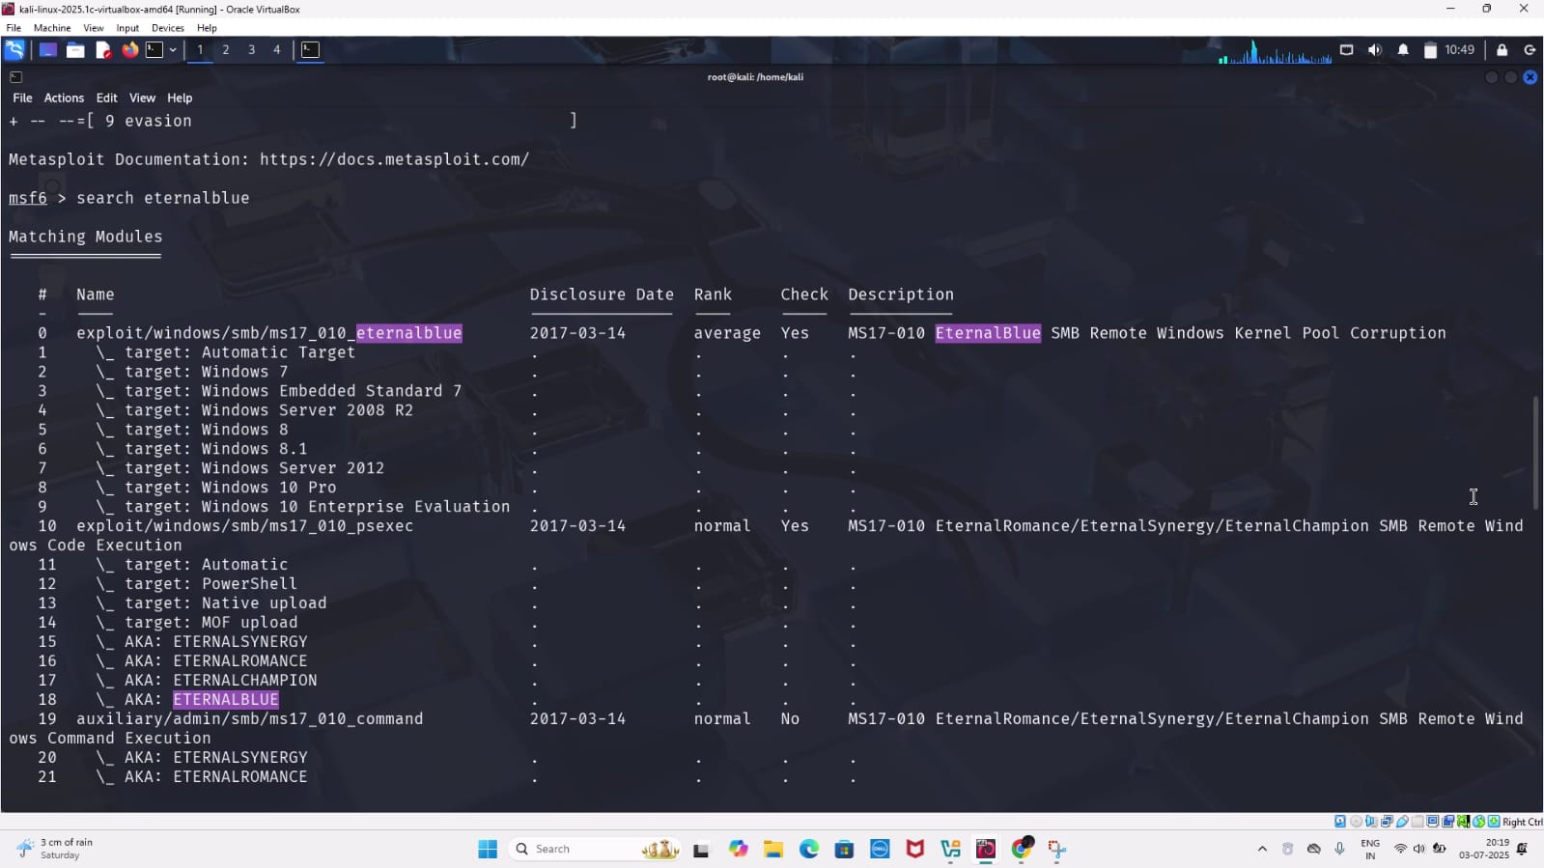
STEP 9: Selecting the Exploit Module
Use the following command to select the EternalBlue exploit:
use 0
This loads the module:
exploit/windows/smb/ms17_010_eternalblue
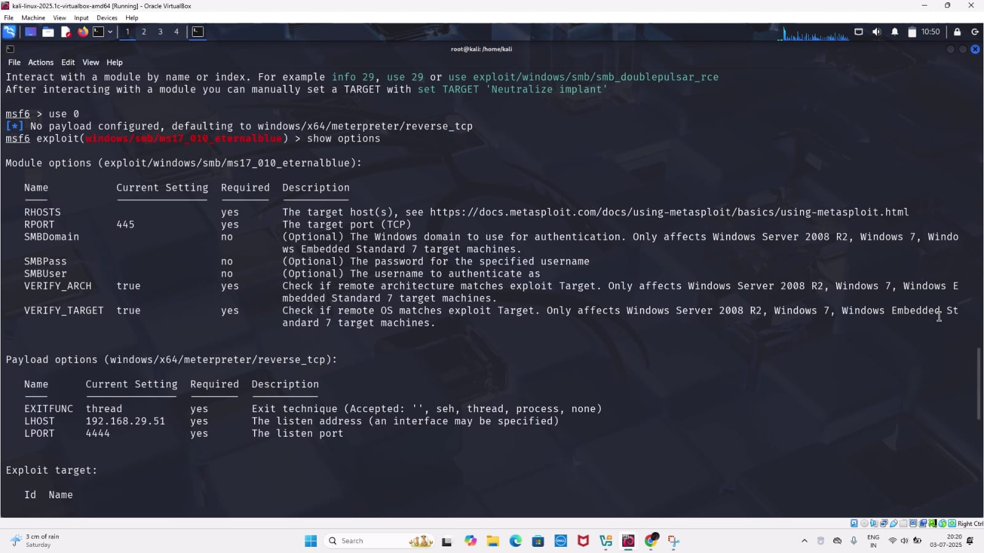
STEP 10: Viewing Exploit Options
Type show options to view configurable parameters. You’ll notice that the RHOSTS (Remote Host) value is empty and needs to be set.

STEP 11: Setting the Target IP Address
Configure the target IP (Windows 7 machine) by running:
set rhosts 192.168.29.79
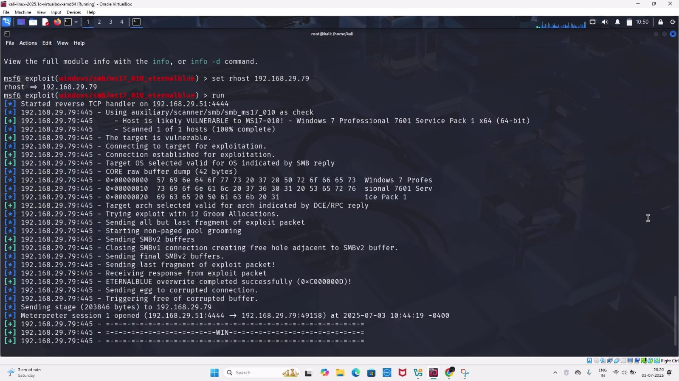
STEP 12: (Optional) Selecting a Payload
If desired, list available payloads using:
show payloads
Then set a specific payload using:
set payload <payload_name>
This step is useful if custom session behaviour or reverse shell is needed.
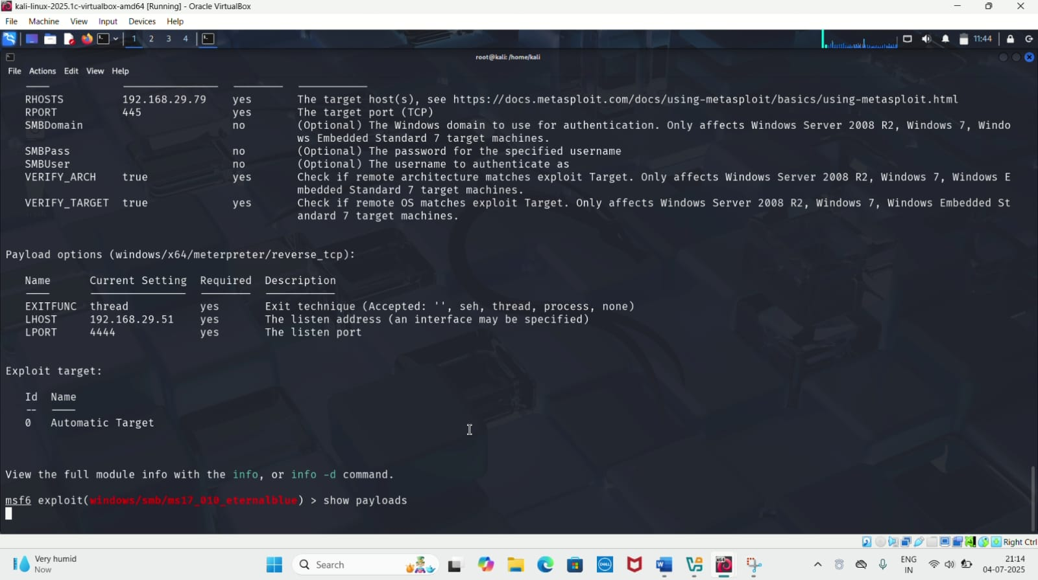
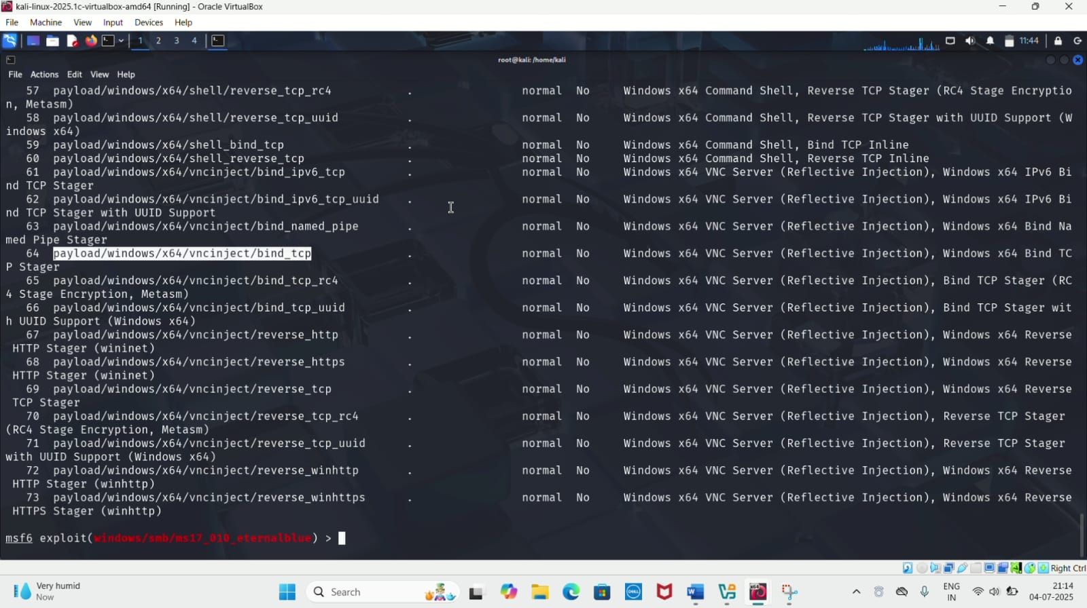
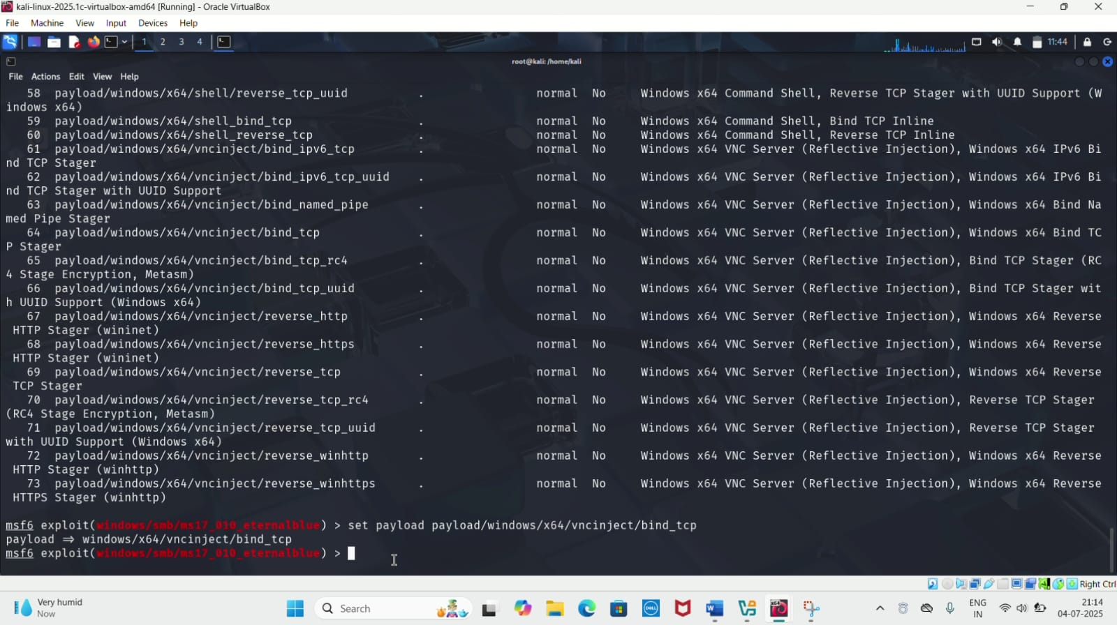

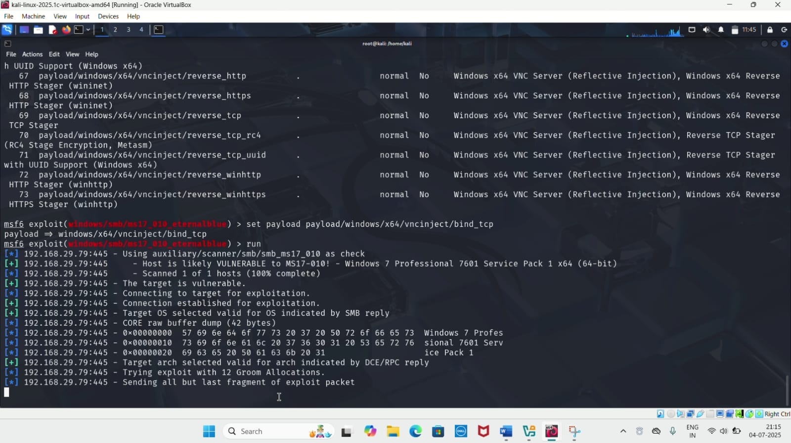

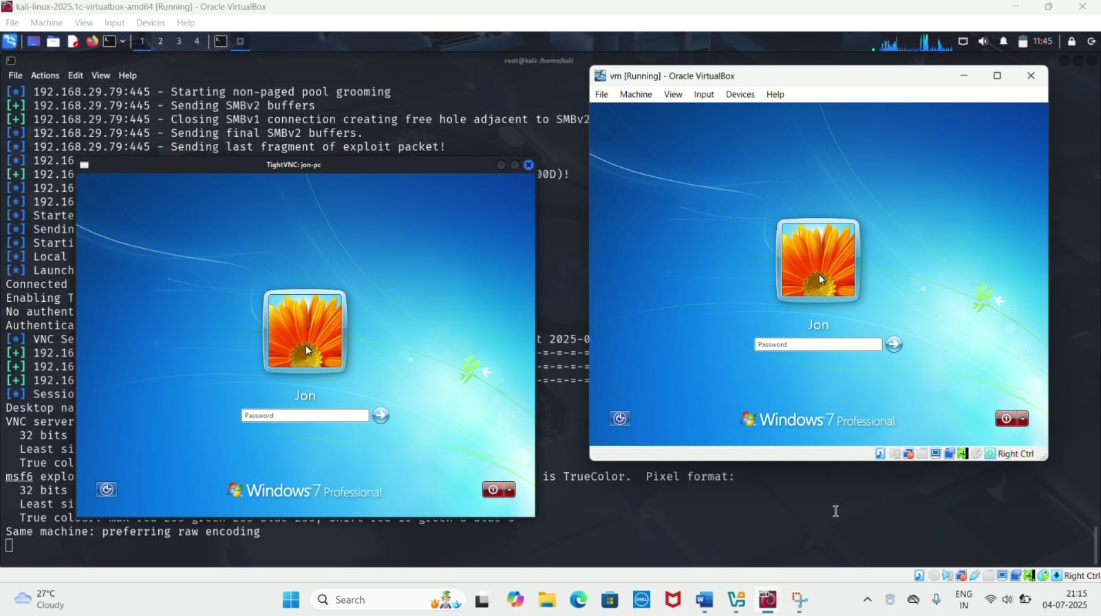
STEP 13: Running the Exploit
Launch the attack using:
run
Upon successful exploitation, a Meterpreter session is opened.
STEP 14: Dumping Password Hashes
Within Meterpreter, execute:
hashdump
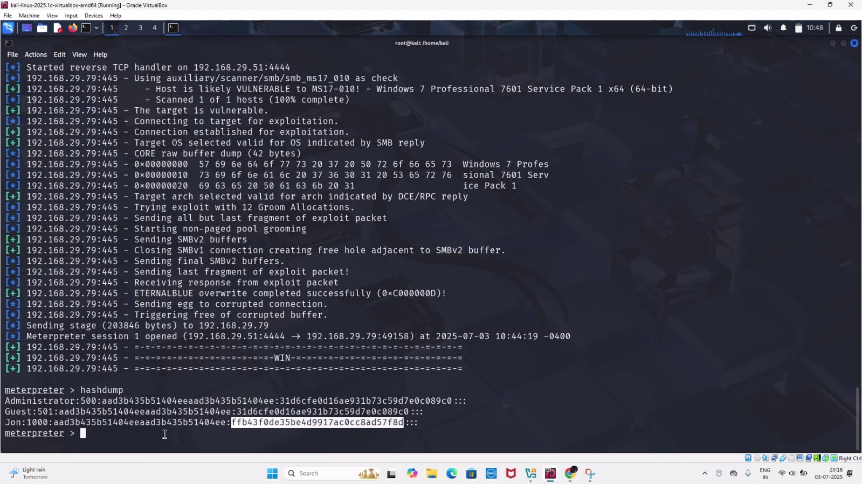
This retrieves the NTLM password hashes of users on the target machine. Among them will be the hash of the JON-PC user account.

STEP 15: Cracking Password Hashes
Copy the desired hash and visit https://crackstation.net, a free online password hash cracker. Paste the hash and initiate the cracking process to reveal the plain-text password.
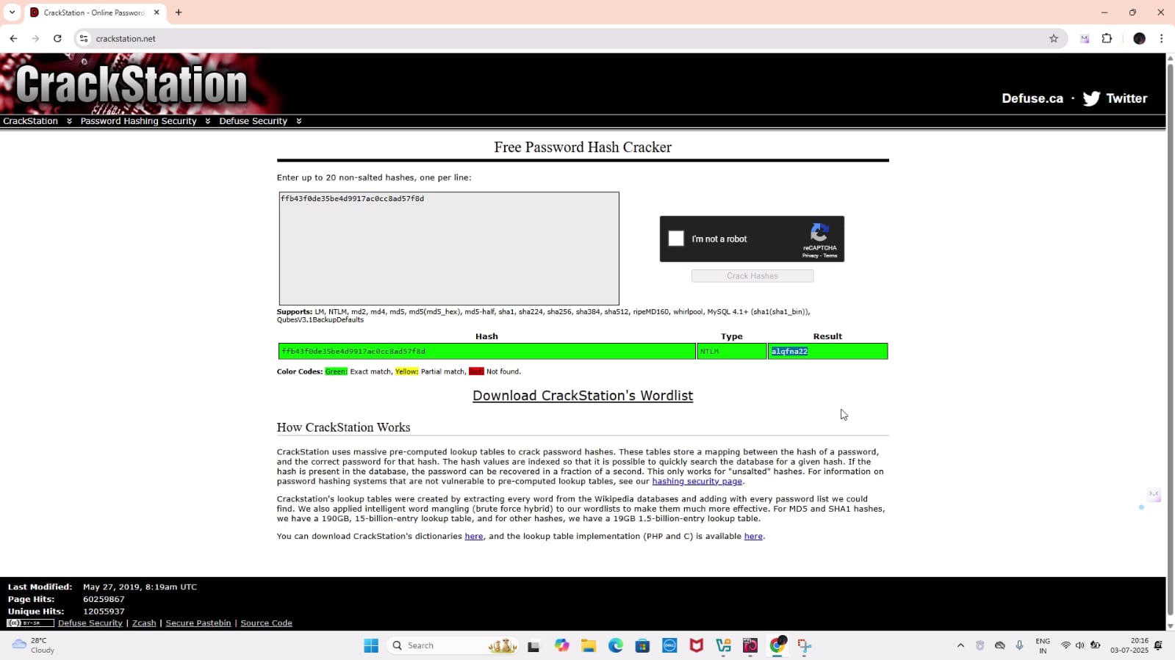
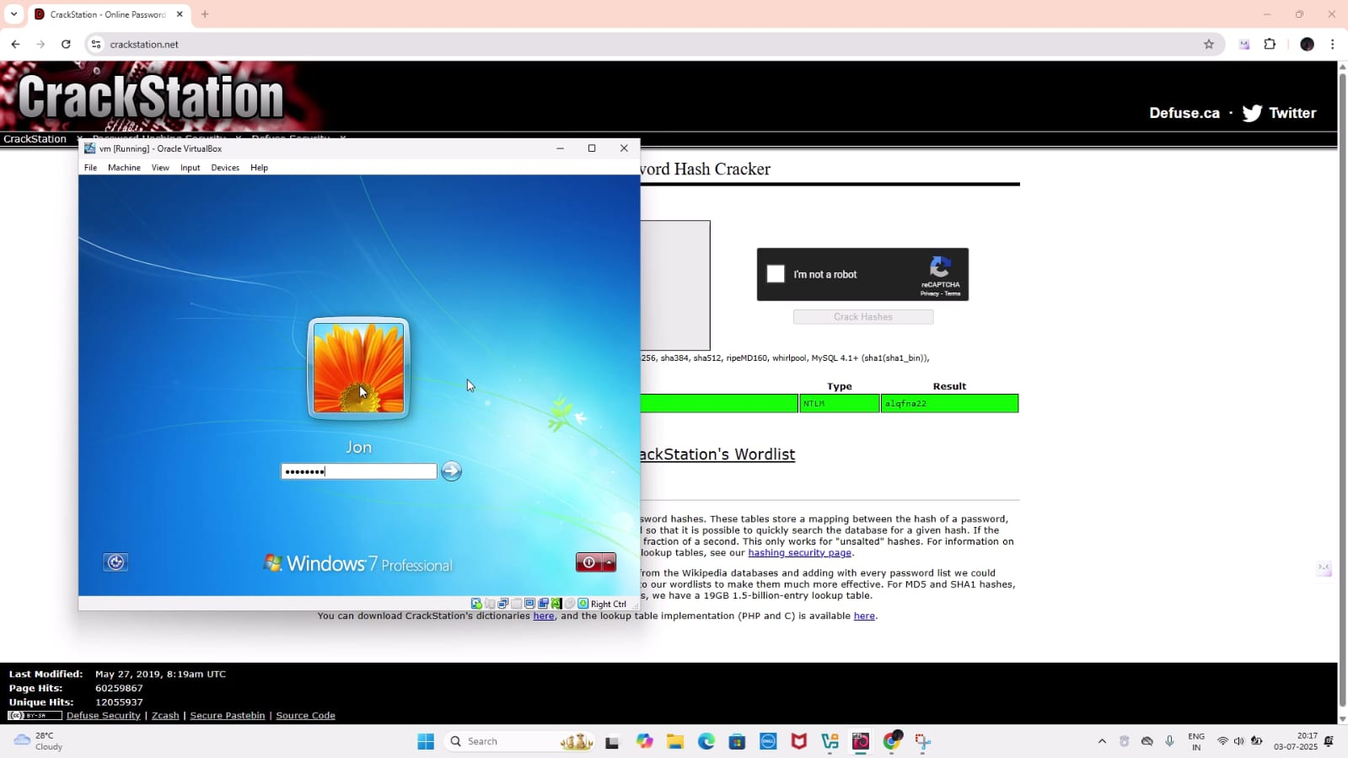
STEP 16: Accessing the Windows Command Shell
Exit Meterpreter using exit or drop to a system shell using:

Shell

You will enter the Windows CLI, typically shown as:
C:\Windows\system32>

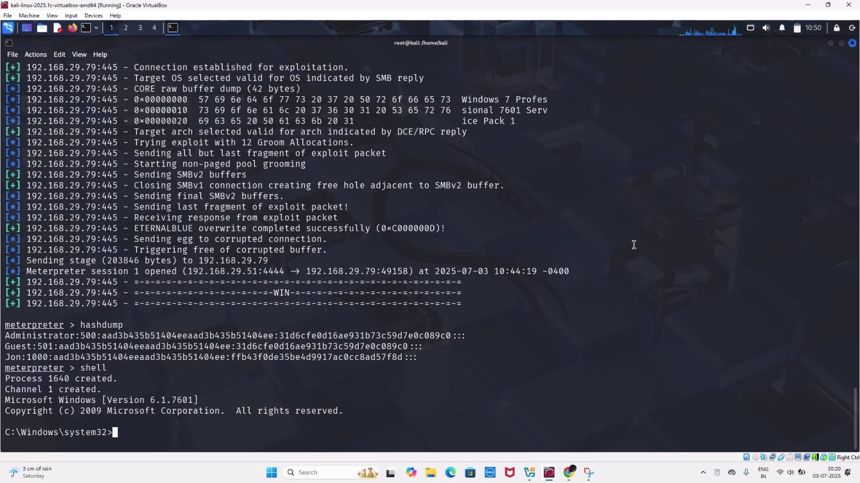

STEP 17: Manipulating the Windows File System
From here, Windows commands such as dir, mkdir, etc. can be used. For example:
mkdir test
dir
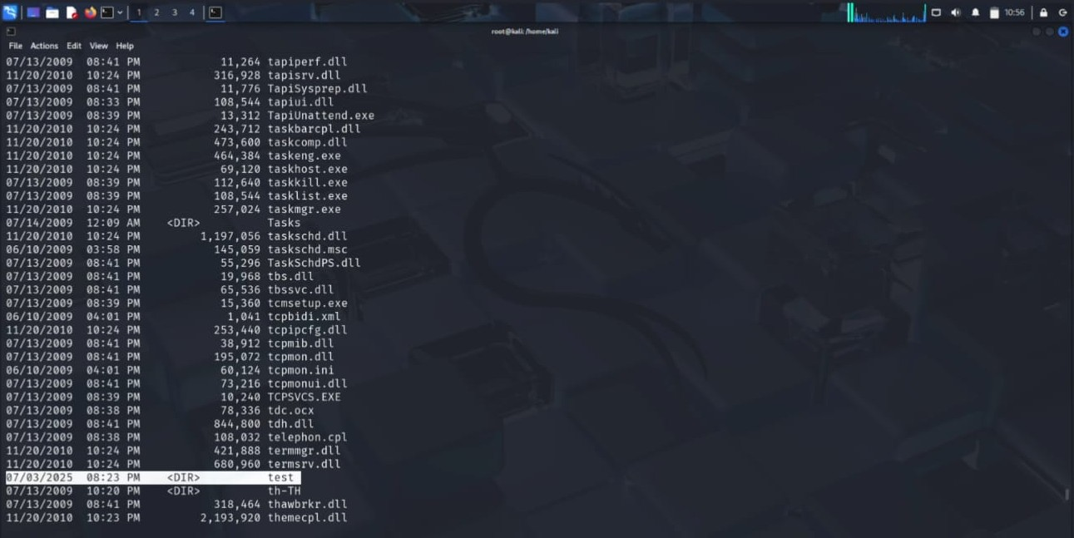
These commands verify folder creation and demonstrate that full control over the Windows 7 system has been achieved.
CONCLUSION
The successful exploitation of the Windows 7 system using Kali Linux in a virtualized environment demonstrates how legacy operating systems remain highly vulnerable to known security flaws, particularly when unpatched. By leveraging tools like Nmap, Metasploit Framework, and nbtscan, and exploiting the EternalBlue (CVE-2017-0143) vulnerability, full access to the target system was achieved, including retrieval of password hashes and direct manipulation of system files via the Windows command shell.
This controlled attack highlights the critical importance of:
- Regular system updates and patch management,
- Network segmentation and monitoring,
- And removing outdated systems from critical infrastructure.
Furthermore, the use of VirtualBox provided a safe and isolated testing environment, ideal for ethical hacking practice and penetration testing training without any risk to real-world systems.
Overall, this practical lab enhances both theoretical and hands-on understanding of how vulnerabilities are exploited, and prepares cybersecurity learners to better secure and defend systems in real scenarios.

